Sarah Hoffman 11/23/20 lab

Main Page:

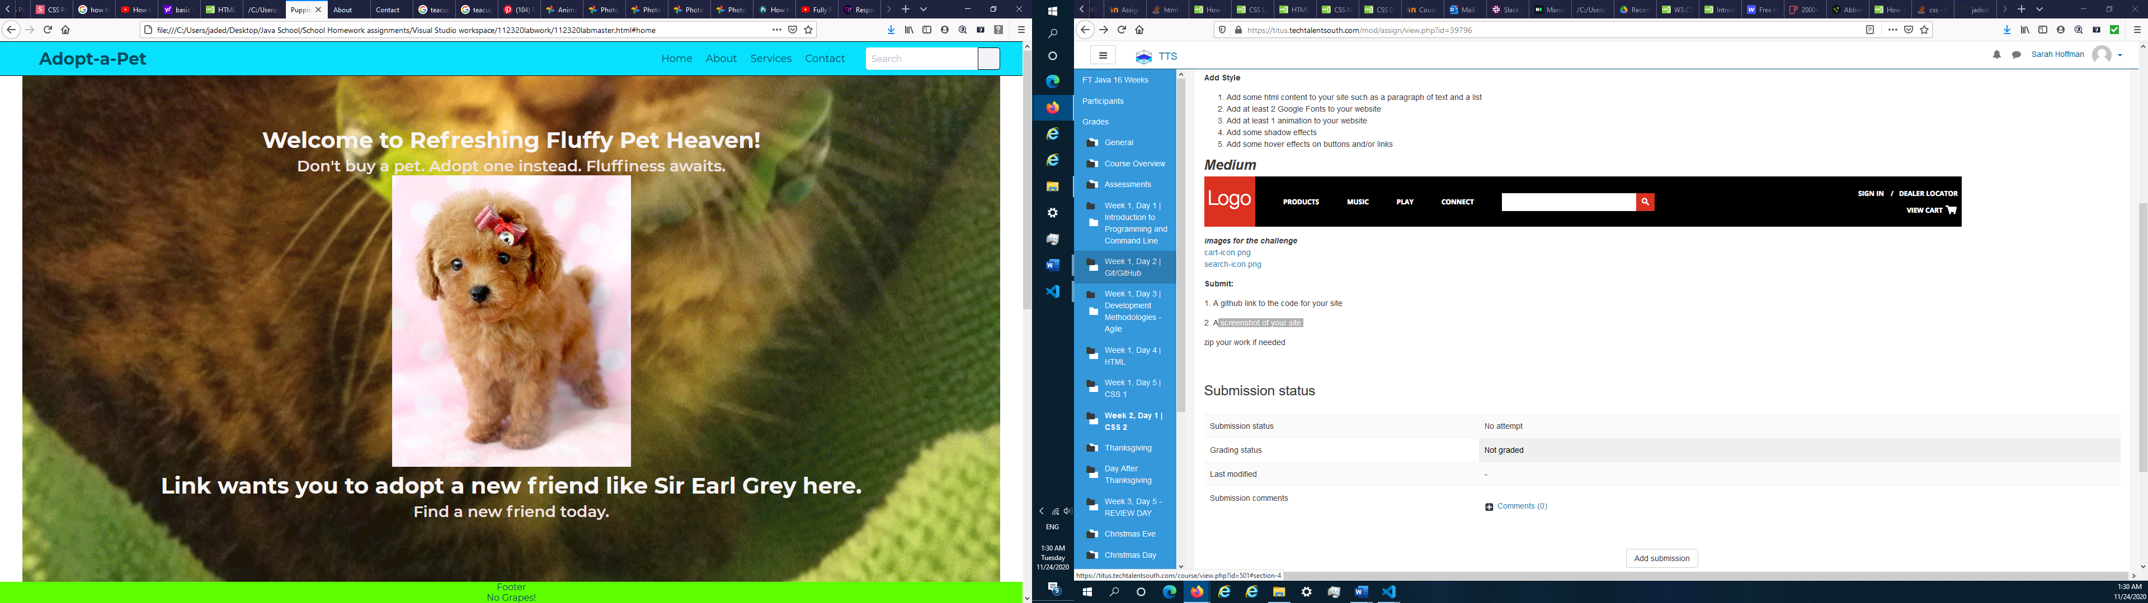

About Page:

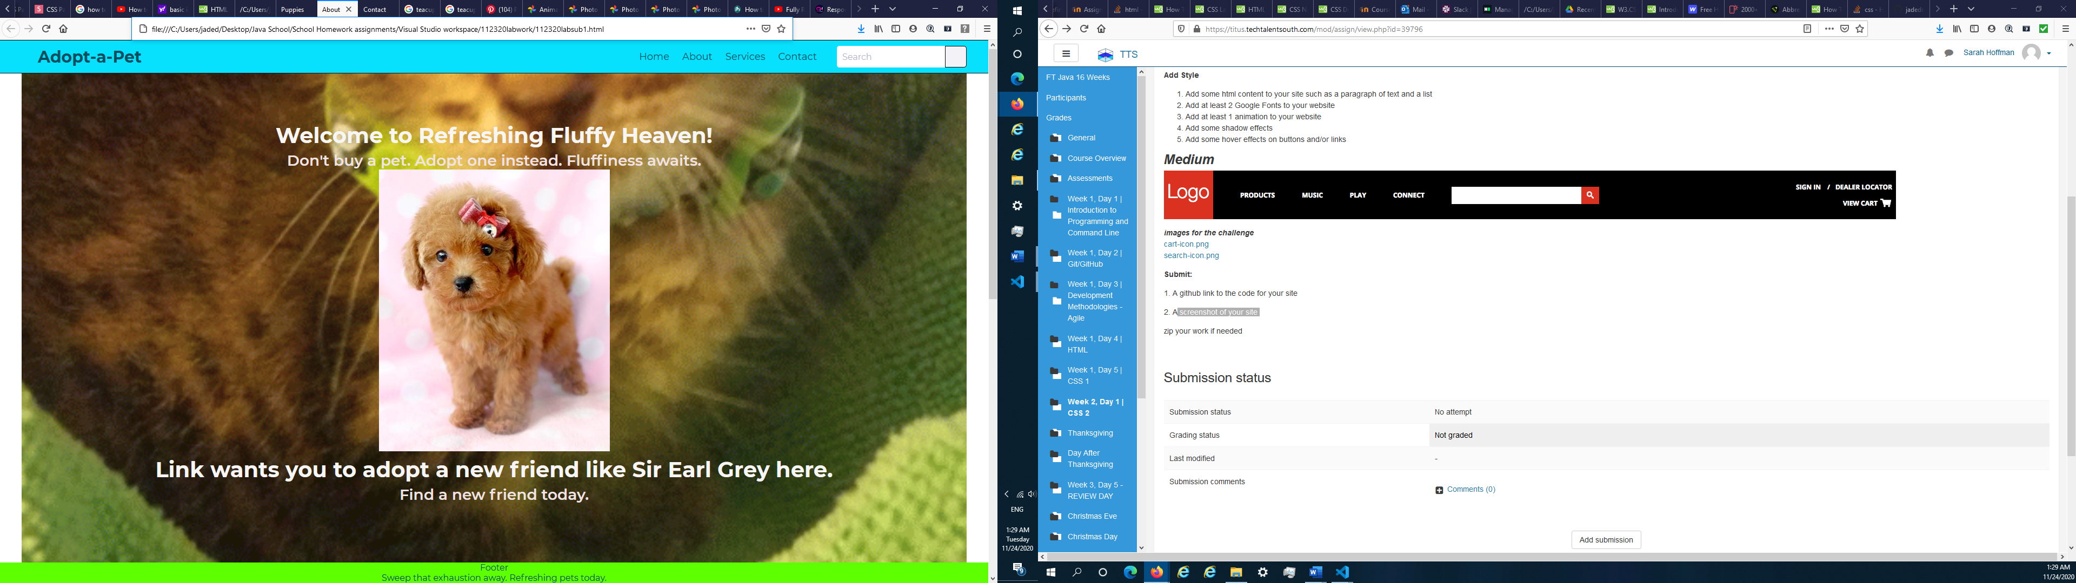

Contact Page:

